A House That Will Last

Introduction…Luke 6:46-49
- A house without a foundation…when the torrents strike, it will collapse and be destroyed
- A house with a foundation on rock…dug down deep, well built…when floods come, cannot be shaken and will last

A. Built On A Pattern
1. 1 Corinthians 3:10-17…civilizations that have left a lasting impression build
- Rome colosseums and temples…European castles and cathedrals…Aztec and Mayan temples…Egyptian pyramids…Great Wall of China
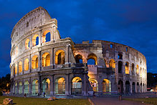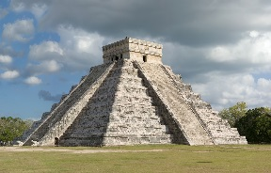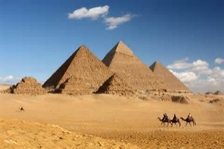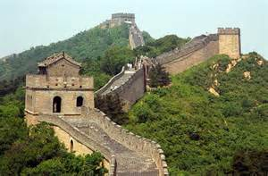
- Nomads don’t have much to leave…a tent…a horse
- The church is people, but God clearly likes to build
2. Psalm 127:1-5…built by the Lord and for the Lord
- Paris…Napoleon’s Arch of Triumph…today’s Grand Arch, “built for the glory of man”
- Joshua 24:15b “But as for me and my household, we will serve the Lord.”
3. Hebrews 8:5b…God has given us building plans…blueprints to live by
- There is a clear PATTERN of success to build your house
- It will take PERSEVERANCE…dedication…consistency
- You will enjoy the blessing of God’s PRESENCE filling your house
- You will be able to successfully PASS ON generational blessing

B. Built On A Solid Foundation
1. 1 John 1:5-10…Lies destroy a house…truth and honesty build a house
2. James 3:13-16…Envy destroys a house…Love builds a house
3. Ephesians 5:5…Greed destroys a house…Generosity builds a house
4. Ephesians 4:30-32…Bitterness destroys a house…Forgiveness builds a house
5. 1 Corinthians 13:4-8a…Harshness destroys a house…Kindness builds a house
6. Ephesians 4:1-6…Division destroys a house…Unity builds a house
7. Ephesians 4:29…Gossip destroys a house…Healthy Communication builds a house
- The tower of babble…Proverbs 12:18
- This is so important…Proverbs 18:8, Proverbs 20:19, Proverbs 26:20
- A few years ago we had an issue with gossip…we met with individuals and brought truth to the issues…but what made the difference was that in prayer I drove out the spirit of gossip…I said, Lord if the people want to change, we’ll keep the people…but the spirit must leave our church…interestingly, one person stayed and grew…the other two left

C. Built On the Rock
- Matthew 16:13-19…a house built on the rock with a solid foundation
- Peter was not completely solid…shifting sands…denied the Lord
- Jesus calls Himself the Rock…and He calls Peter a rock
- A house built on Christ will last…it will withstand storms…and for generations
- You have keys to your house…lock out the devil and his works…open up for God’s glory
  - Bind (deo) …Matthew 22:13 “tie him hand and foot”
  - Loose (luo) …John 11:44 “take off the grave clothes and let him go” (NIV)
“unbind him and let him go” (NASB)

- Last House Standing
- On September 13, 2008, Hurricane Ike made landfall on Galveston Island in Texas as a Category 2 hurricane but with a storm surge of a category 4…the storm devastated the Gulf coast…Warren and Pam Adams built a beautiful home in Gilchrest, which is just northeast of Galveston
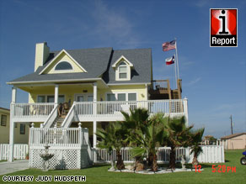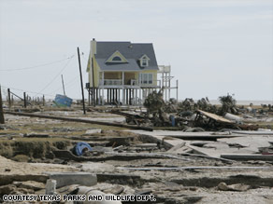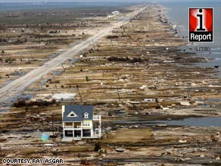
- Associated Press: “Warren Adams credited his home’s survival to several reasons: It was built higher off the ground than surrounding houses and its foundation was made of reinforced concrete. Also, the house, completed last year, was built to new hurricane building codes.”

